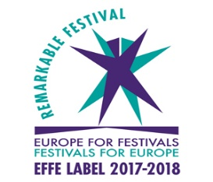

21 January 2019

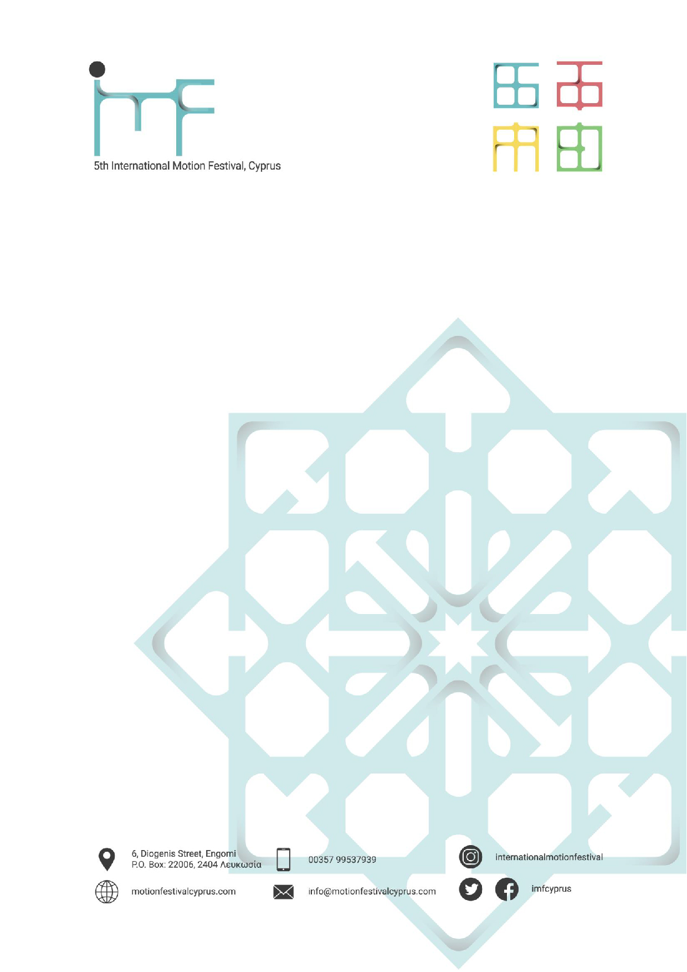
International Motion Festival 2019
Call for volunteers

What is the International Motion Festival?
The International Motion Festival was launched in 2012 and is a bi-annual festival (2013, 2015, 2017 editions), organised by the Arts Department of the European University of Cyprus. The International Motion Festival (IMF) is the first of its kind, both in Cyprus and the broader Mediterranean and Middle East region and it aims to bring together film-makers, video artists, computer animators, graphic designers and their audience and to familiarise the public with what has traditionally been described as the "invisible art"; motion graphics.

Some highlights from the International Motion Festival – IMF:

- It is a four-day festival
- The Festival developed into a Competition Festival, with prizes in 4 film Award categories (for students and professionals)
- Including an Award Ceremony
- There are numerous screenings, hosting of other international festivals, presentations and workshops by industry leaders and academicians, both from Cyprus and abroad
- The 2019 edition will take place on week days (as opposed the weekend, with the Award Ceremony taking place on Thursday evening (last evening of the festival)
- This year 214 films (out of almost 354 submissions) were selected from 56 countries to be showcased during the festival; 40 films are short-listed.

Why should you get involved?

We are looking for enthusiastic people who will form the core team of volunteers for the event, and who are willing to offer their time and expertise to help in the smooth management of this unique event. As a volunteer you will be an integral part of the International Motion Festival team working with staff members and partners to run the event. You will be allocated a specific role, in consultation, but should be flexible and happy to help with other tasks where needed. You will be part of a multi-national team and gain new experience in all aspects of making a city festival happen.

Criteria to apply as a volunteer

• Be aged at least 18
• Have experience in organizing or supporting (international) events or Graphic design experience
• Be a flexible team-player with good communication skills
• Have a good command of English (knowledge of other EU languages is an asset)
• Live within close proximity to Nicosia*

Furthermore, by applying as a volunteer, you commit to:

• Be available for the preparation of the event and the event itself on 5-7 May 2019 and/or for the preparatory phase 15- April to 15 of May 2019
• Take an active part in all stages of the preparation, in close co-operation with the team.

Your main responsibilities as a volunteer

As a volunteer you will be mainly responsible for:

• Being part of or leading a team of volunteers assigned with a specific tasks on the days of the Festival
• Providing information and orientation to participants
• Developing and running specific programme elements
• Supporting collaborating organisations and partners in setting up and running their activities
• Managing spaces (meeting artists, speakers and participants, preparing the rooms/spaces, ensuring IT and other material is in place and properly used)
• Facilitating performance spaces and supporting artists to ensure performances run smoothly
• Other tasks defined in consultation with you

In addition to these general responsibilities we are looking for a number of more specific profiles for the different roles below. Please indicate in your application if you would be interested in taking on one of these specific roles.

Co-ordination

Do you have experience in managing a team? Are you stress-resistant with great organisation and communication skills? We are looking for two co-ordinators responsible for managing the volunteers on-site and making sure their needs and expectations are met.

Communication

Are you passionate about communication and social media? Do you have specific skills such as graphic design or copy writing? Are you a keen photographer or video-maker? We are looking for two volunteers to support the Urban Emptiness Festival communication team and for (live) coverage of the event.

Event management

Do you have experience with event management? We are looking for one or two volunteers to support the implementation of our action plan.

Commitments from the International Motion Festival

The International Motion Festival commits to:

• Provide adequate insurance coverage for you while carrying out your volunteering role
• Provide a description of the role offered, its aim and expected learning outcomes
• Provide thorough induction needed to meet the responsibilities of this role
• Provide support and supervision, including with regular contacts and mutual feedback
• Ensure a healthy and safe working environment
• Ensure that all volunteers are dealt with in accordance with equal opportunities policy
• Resolve fairly and swiftly any problems, complaints and difficulties you may encounter while volunteering at the festival
A T-shirt
A badge

Interested? Here are the next steps…

The deadline for applications is February 10 th st 2019, 23:59 CET.
To apply as a volunteer you should send us following application form.
Selected applicants will be contacted latest beginning of February 20 2019.

Any questions?

Get in touch with info@motionfestivalcyprus.com

*for those living abroad please be reminded that you can use the Erasmus Internship Program to fund your travelling expenses and accommodation.

International Motion Festival, Cyprus
[e] info@motionfestivalcyprus.com
[w] www.motionfestivalcyprus.com

